80% Vaccination Uptake

Population-wise projections

Cervical Cancer Incidence
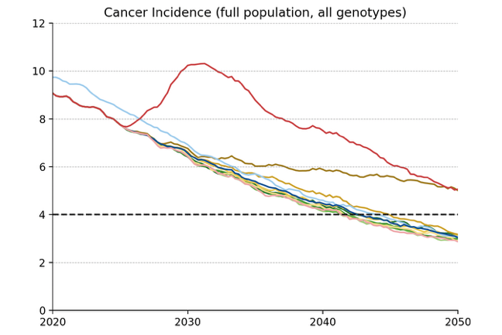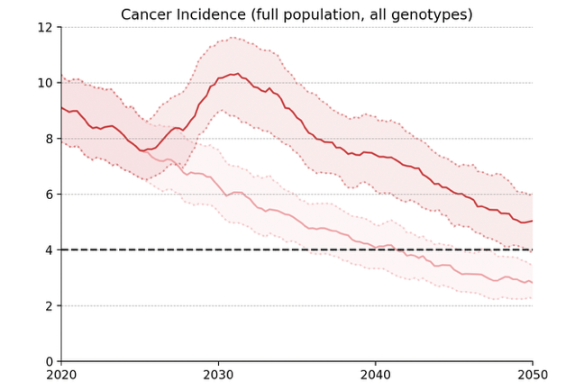
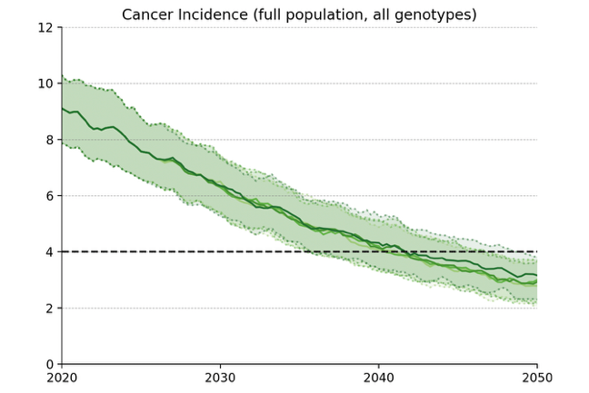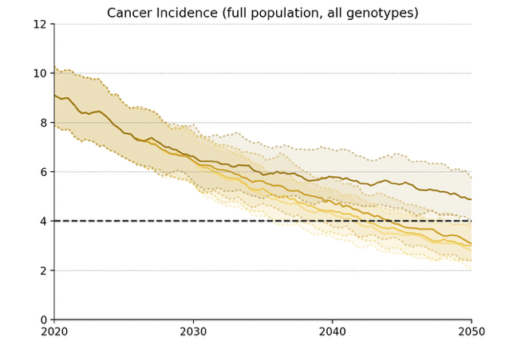
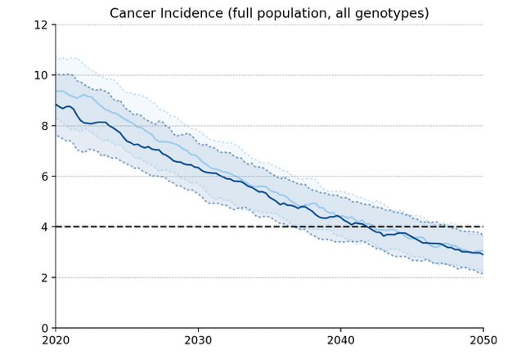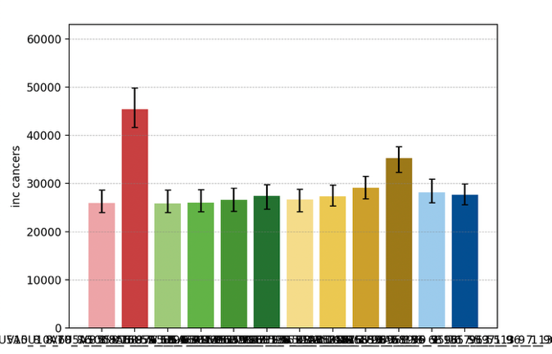
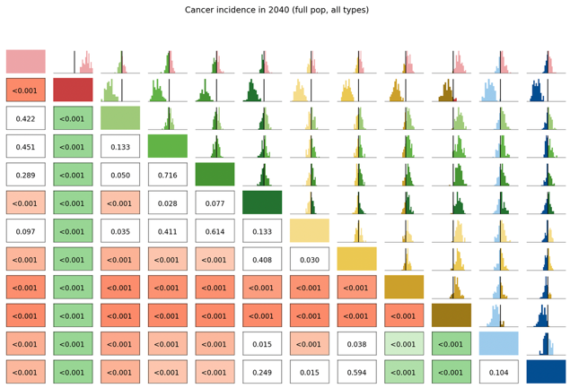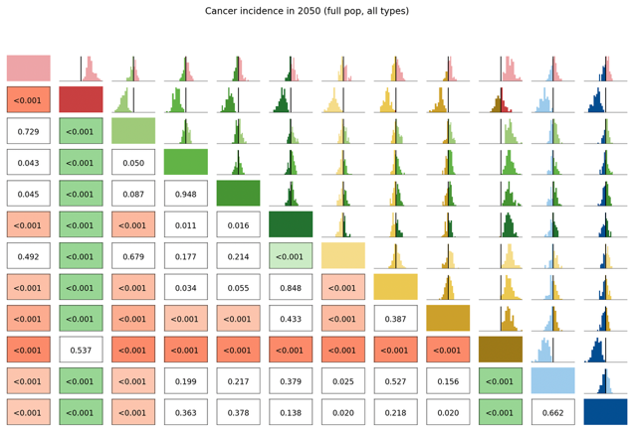

Long Term Undiagnosed Prevalence
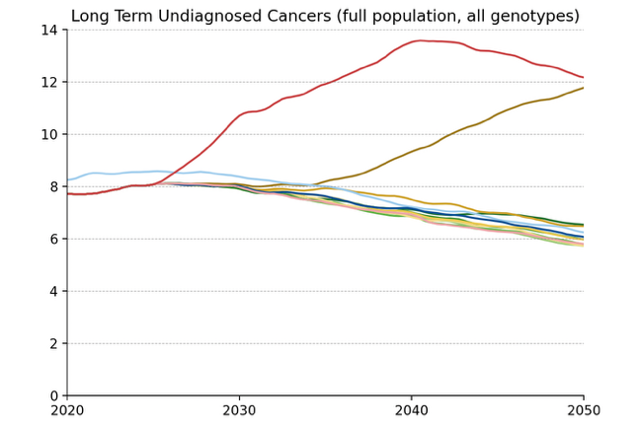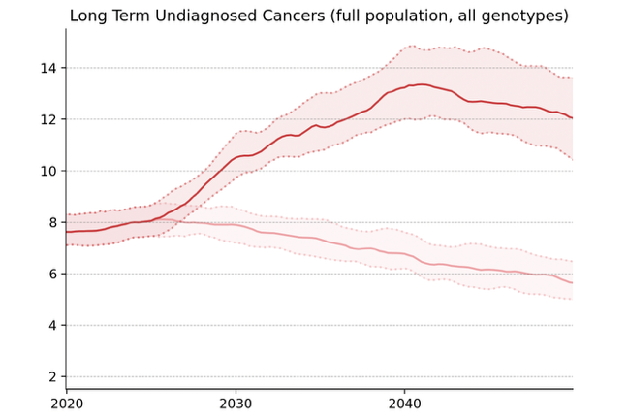
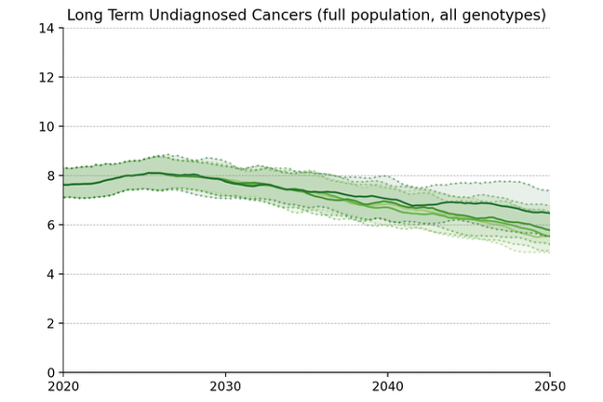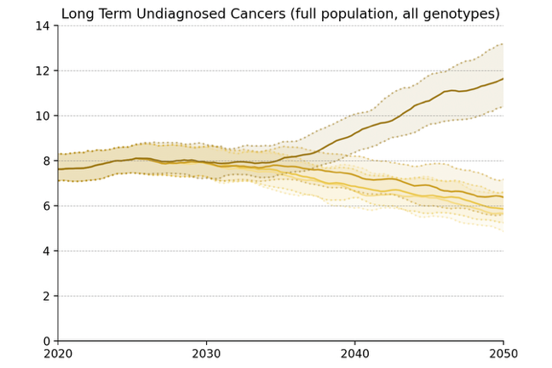
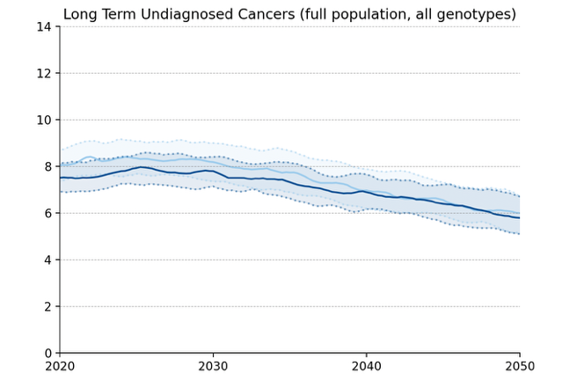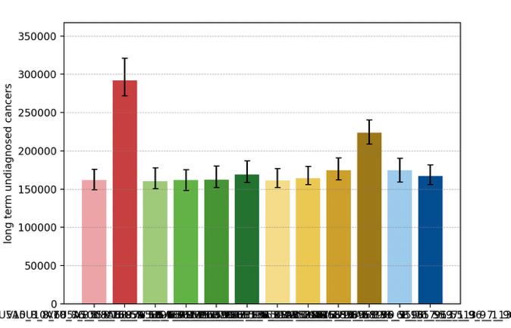
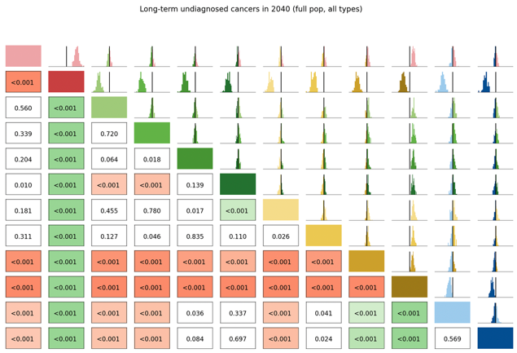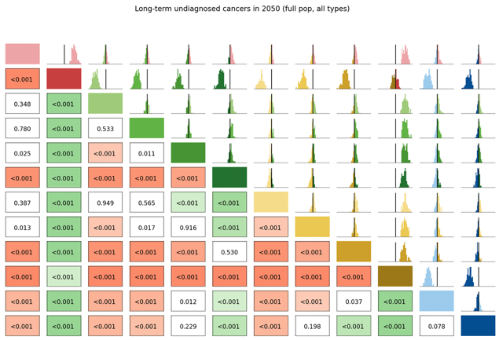

Number of Routine Screens
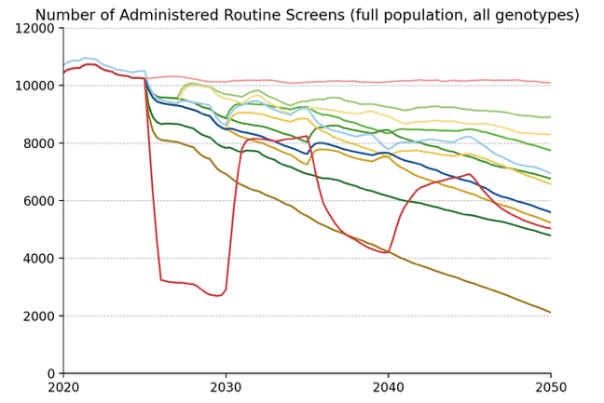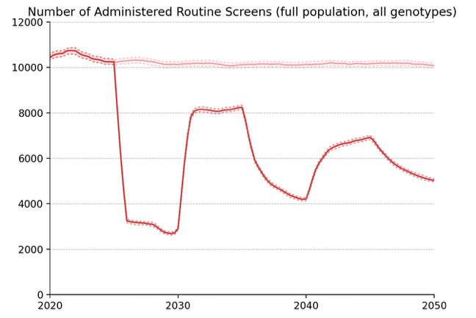
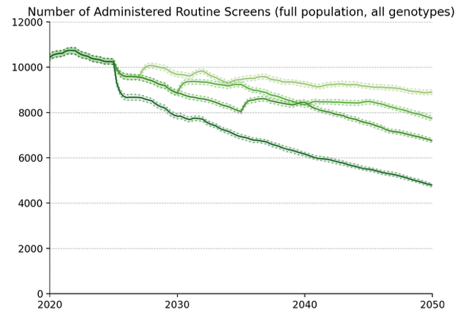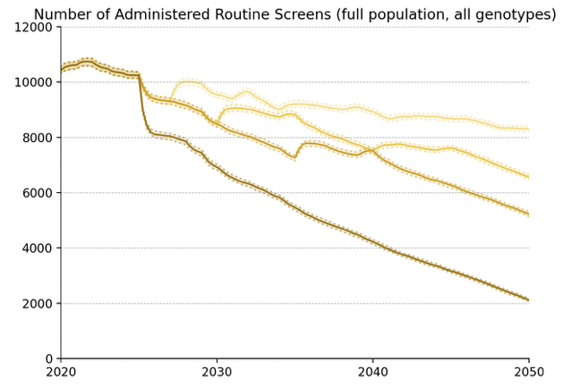
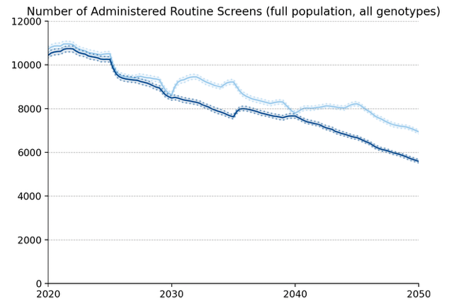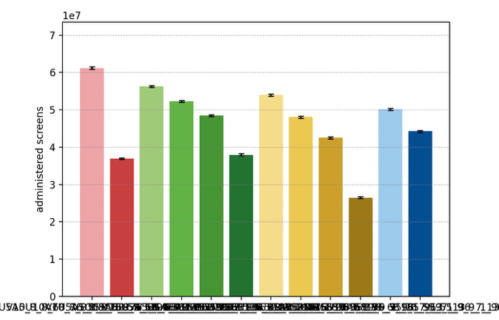

Average Number of Screens per Diagnosed Cancer, 2030-50
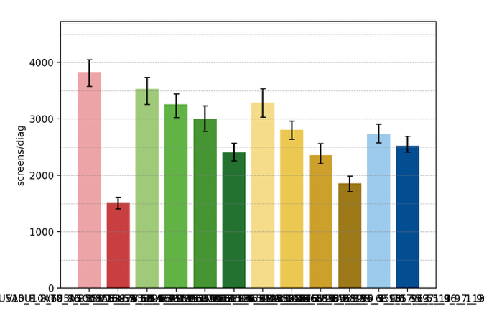

Elimination Probability Table
alg | Elimination Year: Median [LQ, UQ] (_8) | 2040.25 Elimination Probability (_8) | 2050.25 Elimination Probability (_8)
V5U5A5 | 2045 [2042, 2049] | 0.160 | 0.795
V7U5A5 | 2045 [2042, 2049] | 0.133 | 0.795
V10U5A5 | 2046 [2043, 2050] | 0.142 | 0.786
V15U5A5 | 2045 [2042, 2050] | 0.142 | 0.786
V_U5A5 | 2048 [2044, 2052] | 0.089 | 0.625
V7U7A5 | 2046 [2042, 2050] | 0.124 | 0.795
V10U10A5 | 2048 [2044, 2050] | 0.071 | 0.768
V15U15A5 | 2048 [2045, 2052] | 0.053 | 0.607
V_U_A5 | 2055 [2054, 2055] | 0.017 | 0.044
V10U7A5 | 2048 [2044, 2051] | 0.044 | 0.697
V15U10A5 | 2048 [2044, 2051] | 0.089 | 0.688
V10U10A10 | 2055 [2053, 2055] | 0.017 | 0.035
Maximum margin: 0.09042877397980524

Vaccinated Subpopulation projections

Cervical Cancer Incidence

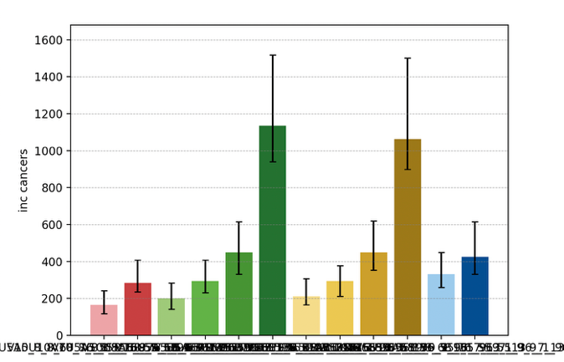
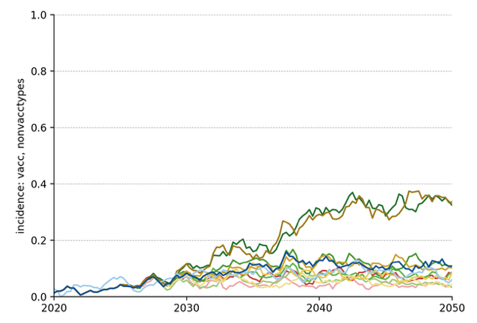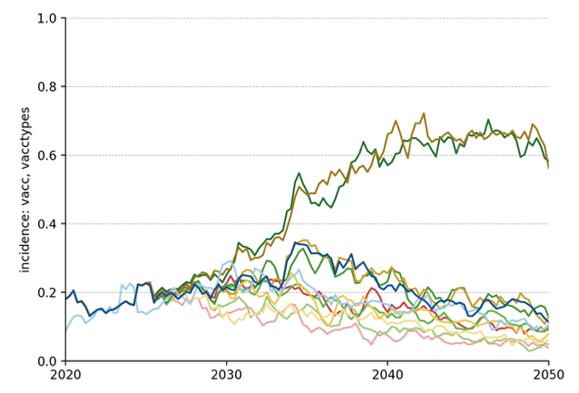
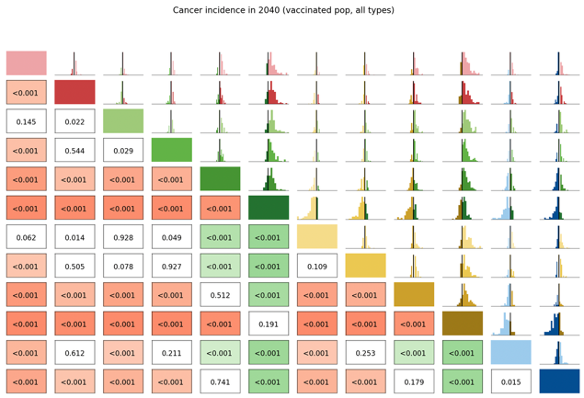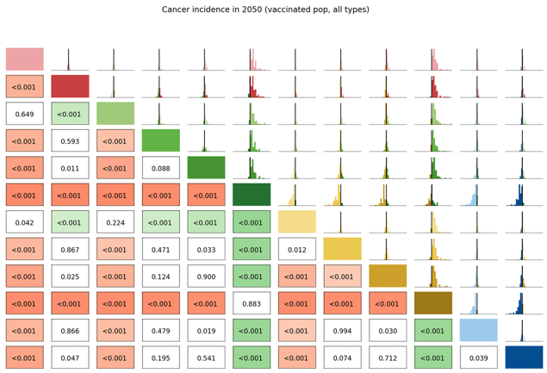

Long Term Undiagnosed Prevalence
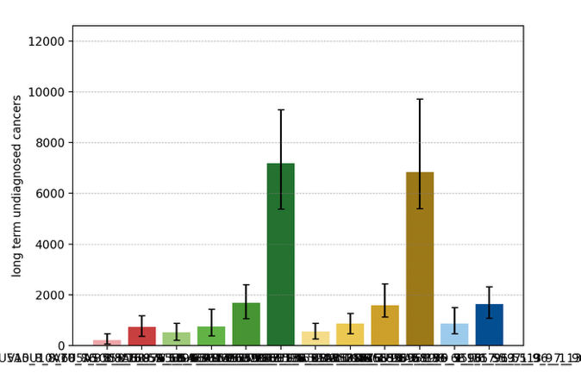
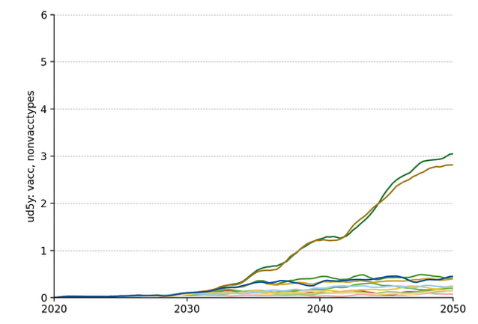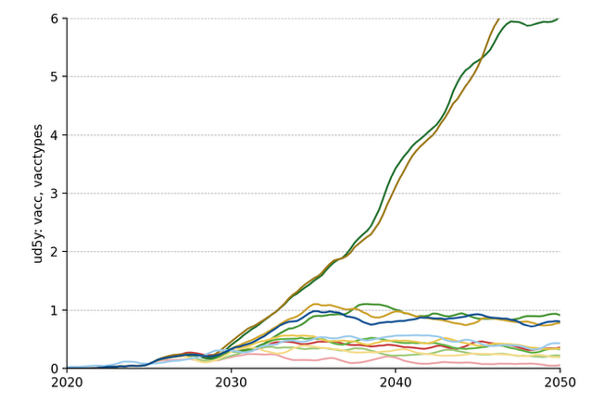
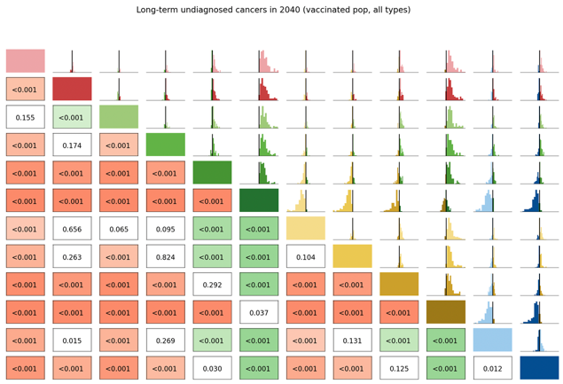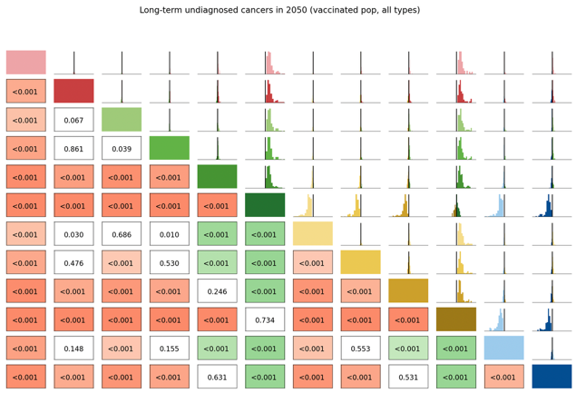

Number of Routine Screens
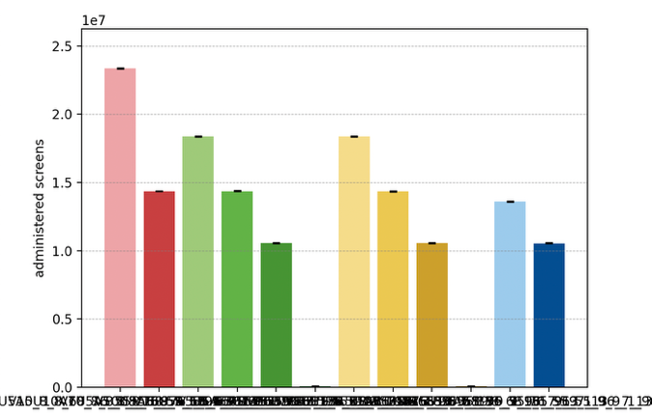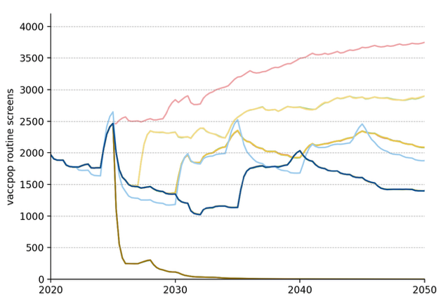

Average Number of Screens per Diagnosed Cancer, 2030-50
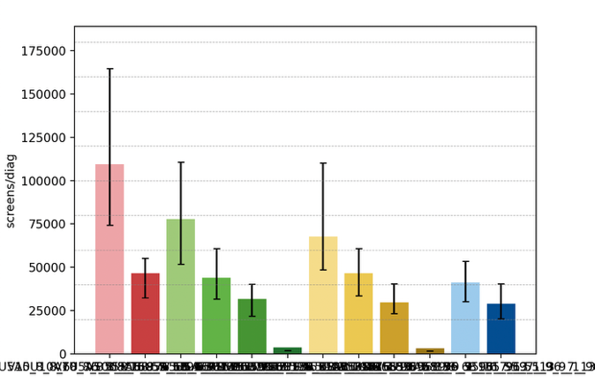

Elimination Probability Table
alg | Elimination Year: Median [LQ, UQ] (_8) | 2040.25 Elimination Probability (_8) | 2050.25 Elimination Probability (_8)
V5U5A5 | 2008 [2008, 2008] | 0.983 | 0.983
V7U5A5 | 2008 [2008, 2008] | 0.983 | 0.983
V10U5A5 | 2008 [2008, 2008] | 0.983 | 0.983
V15U5A5 | 2008 [2008, 2008] | 0.983 | 0.983
V_U5A5 | 2008 [2008, 2008] | 0.929 | 0.956
V7U7A5 | 2008 [2008, 2008] | 0.983 | 0.983
V10U10A5 | 2008 [2008, 2008] | 0.983 | 0.983
V15U15A5 | 2008 [2008, 2008] | 0.983 | 0.983
V_U_A5 | 2008 [2008, 2008] | 0.920 | 0.956
V10U7A5 | 2008 [2008, 2008] | 0.983 | 0.983
V15U10A5 | 2008 [2008, 2008] | 0.983 | 0.983
V10U10A10 | 2008 [2008, 2008] | 0.983 | 0.983
Maximum margin: 0.04801408640179341

Unvaccinated Vaccine Eligible Subpopulation projections

Cervical Cancer Incidence
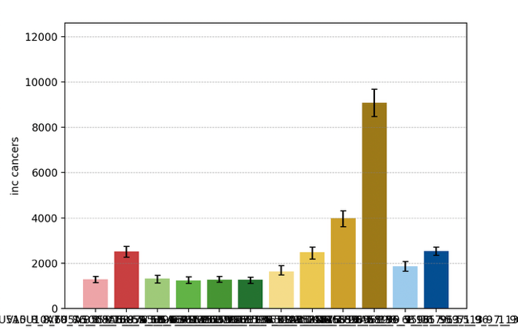
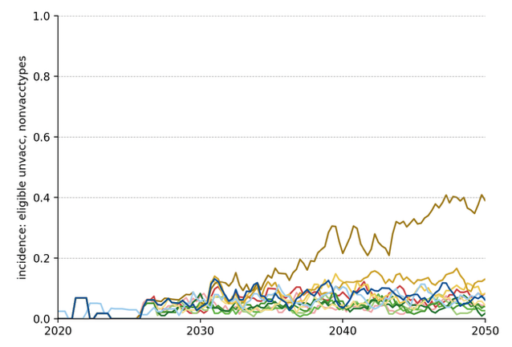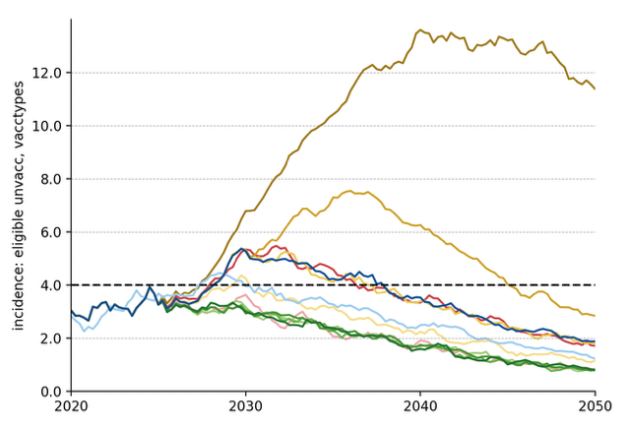
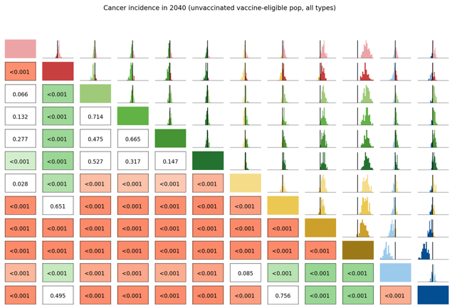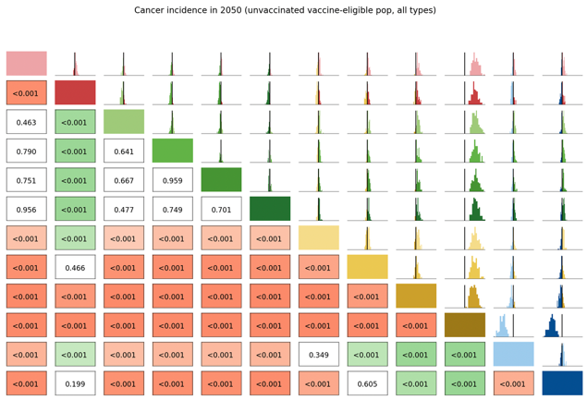

Long Term Undiagnosed Prevalence
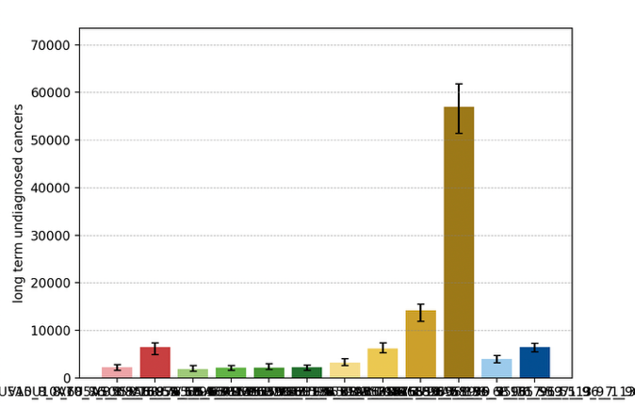
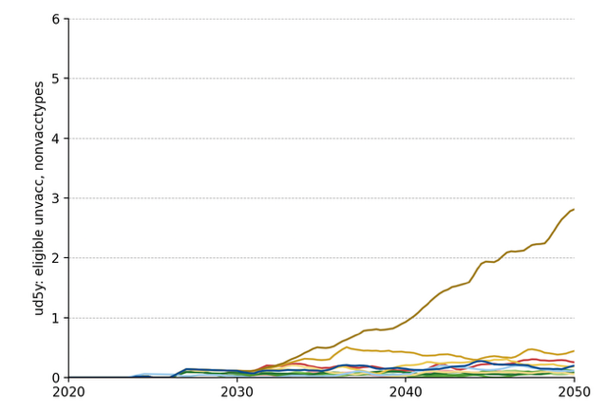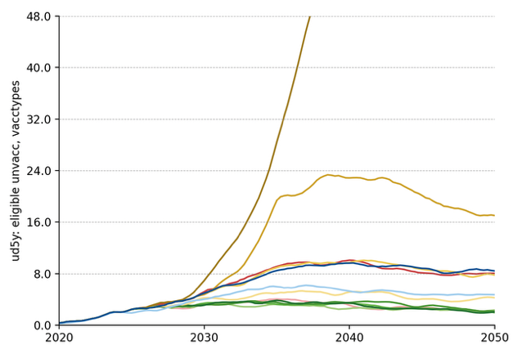

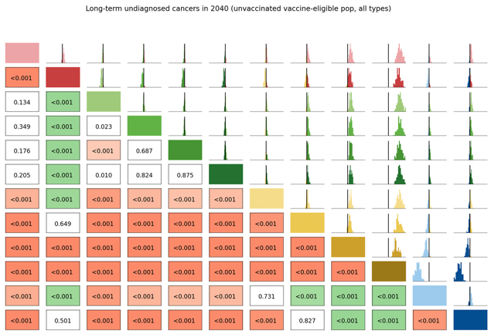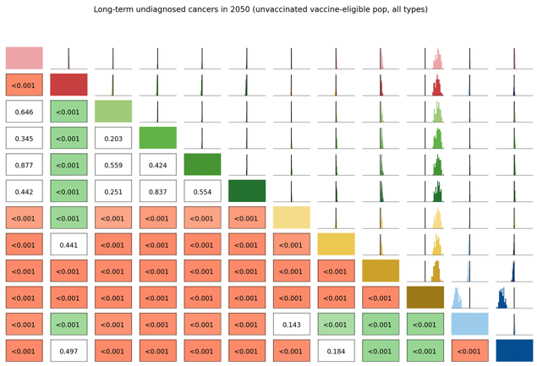

Number of Routine Screens
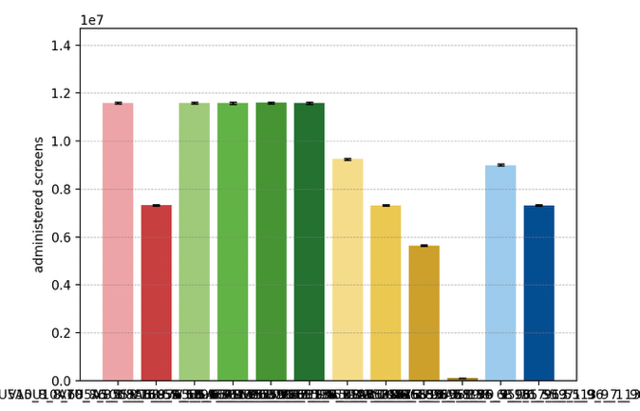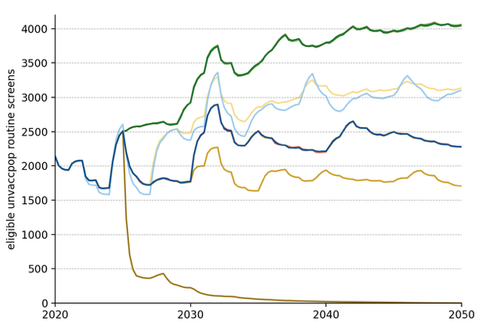

Average Number of Screens per Diagnosed Cancer, 2030-50
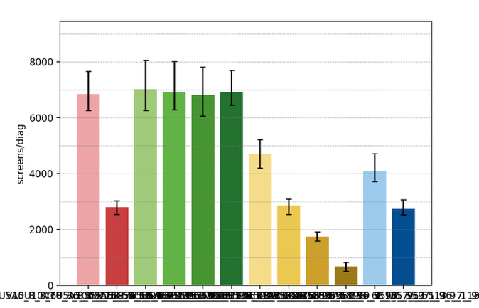

Elimination Probability Table
alg | Elimination Year: Median [LQ, UQ] (_8) | 2040.25 Elimination Probability (_8) | 2050.25 Elimination Probability (_8)
V5U5A5 | 2036 [2033, 2039] | 0.813 | 0.983
V7U5A5 | 2036 [2033, 2038] | 0.813 | 0.983
V10U5A5 | 2036 [2033, 2038] | 0.831 | 0.983
V15U5A5 | 2036 [2034, 2039] | 0.840 | 0.983
V_U5A5 | 2036 [2034, 2038] | 0.840 | 0.983
V7U7A5 | 2039 [2037, 2042] | 0.572 | 0.965
V10U10A5 | 2046 [2043, 2049] | 0.116 | 0.795
V15U15A5 | 2052 [2050, 2054] | 0.017 | 0.294
V_U_A5 | 2056 [2056, 2056] | 0.017 | 0.017
V10U7A5 | 2042 [2038, 2044] | 0.357 | 0.956
V15U10A5 | 2046 [2043, 2048] | 0.071 | 0.858
V10U10A10 | 2046 [2043, 2049] | 0.080 | 0.786
Maximum margin: 0.09167797041647513

